Requirements for this paper:
 | Multi choice cards: |  | Programmable calculator: |  |  |  |  |  | Open book examination
 | Graphic paper: |  | Laptop:
EKSAMEN/  EXAMINATION: |  |  |  | Semestertoets 2 Semester test 2 | kwalifikasieprogram/  /QUALIFICATION program: |  |  |  |  | BIng / BEng
modulekode/  Module CODE: |  |  |  | EERI 423 |  |  |  |  | duur/  duration: |  | 1 uur / 1 hour
module beskrywing/ module description: |  |  |  | Telekommunikasie / Telecommunication |  |  |  |  | maks / max: |  | 50
EKSAMINATOR(E)/  examiner(s): |  |  |  | Prof J.E.W. Holm |  |  |  |  | datum /  date: |  | 2015-09-21
 |  |  |  |  |  |  |  |  | tyd / time: |  | 8:00
moderator: |  |  |  | Mnr Christo van der Merwe

Totaal / TOTAL: 50
Vraag 1 / Question 1 - [20]
1.1) Teken die blokdiagram van ‘n moderne ontvanger en benoem elke element duidelik. / Draw the block diagram of a modern receiver and name each element clearly. [10]
1.2) Gee twee oplossings vir die beeldfrekewensie probleem by RF ontvangers. / Give two soutions to the image frequency problem of RF receivers. [2]
1.3) Noem al die bronne van interne en eksterne ruis by ontvangers. / List all the sources of internal and external noise in receivers. [8]
Vraag 2 / Question 2 - [11]
‘n Radio ontvanger het die volgende komponente met geassosieerde winste en verliese: / A radio receiver has the following components with associated gains and losses:

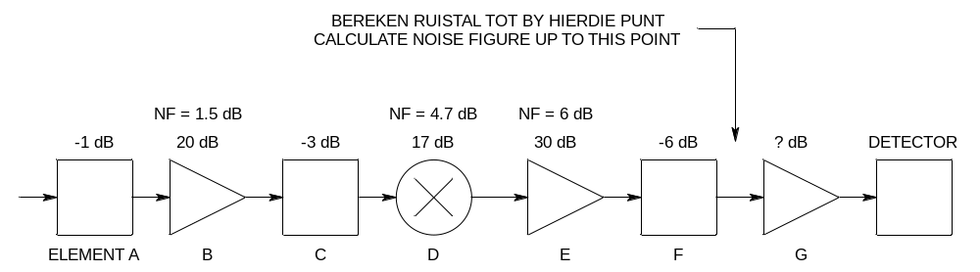
a) Bereken die saamgestelde ruistal van die ontvanger in dB. / Calculate the combined noise figure of the receiver in dB. [6]
b) Wat moet die wins van element G wees om 1 Vrms vir die 1 kΩ detektor te lewer indien die drywing by die inset van element A -95 dBm is? / What must the gain of element G be to provide a voltage of 1 Vrms to the 1 kΩ detector if the input power to element A is -95 dBm? [3]
c) Watter element lewer die grootste bydrae om ruis te beperk, en waarom? / Which element contributes the most to limit noise, and why? [2]
Vraag 3 / Question 3 - [10]
‘n Ontvanger met ‘n 50 Ω insetimpedansie werk by ‘n temperatuur van 25 ºC. ‘n RF sein word ontvang met ‘n bandwydte van 50 kHz. Die seinvlak by die ontvanger is 1 μV_{RMS} en die ontvanger het ‘n saamgestelde ruistal van 4 dB. / A receiver with a 50 Ω input impedance works at a temperature of 25 ºC. A signal is received with a bandwidth of 50 kHz. The signal level at the receiver is 1 μV_{RMS} and the receiver has a noise figure of 4 dB.

a) Bereken die ruisdrywing. / Calculate the noise power. [2]
b) Bereken die seindrywing. / Calculate the signal power. [2]
c) Wat is die sein-tot-ruis verhouding voor die ontvanger? / What is the signal-to-noise ratio before the receiver? [2]
d) Wat is die sein-tot-ruis verhouding by die uitset van die ontvanger? / What is the signal-to-noise ratio at the output of the receiver? [2]
e) Sal hierdie ontvanger digitale data kan ontvang en demoduleer sonder foute – waarom? / Will this receiver be able to receive and demodulate digital data without error – why? [2]

Vraag 4 / Question 4 [9]
4.1) Noem drie soorte multipleksering wat in RF omgewings toegepas word. / List three types of multiplexing used in an RF environment. [3]
4.2) Verduidelik FDM aan die hand van ‘n diagram met ‘n sender en ontvanger. / Explain FDM with reference to a diagram containing a transmitter and receiver. [6] []

Lys van formules / List of formulas

